What are three conclusions we can make about Kickstarter campaigns given the provided data?

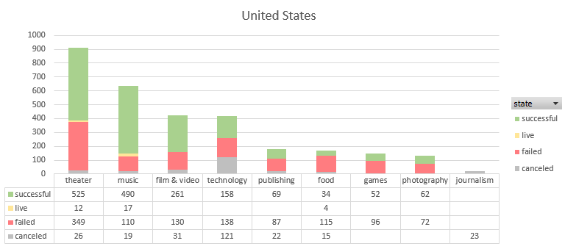

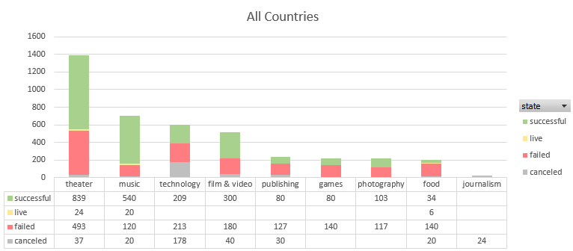

Conclusions:

1. By looking at volume of Kickstarter campaigns – The total across all countries is 4114, and within the US alone is 3038, meaning the US accounts for almost 74% of all campaigns. Therefore, when comparing the graphs of the state of campaigns by category between all countries and the US, you can see that the US is closely representative of the entire sample. When combining all countries and sorting, we can see that the top 3 categories are: Theater (1393), Music (700), and Technology (600). Together these make up 2693, or almost 65% of all campaigns (the top 3 categories in just the US are entertainment-related, with film/video in 3rd place instead of technology).

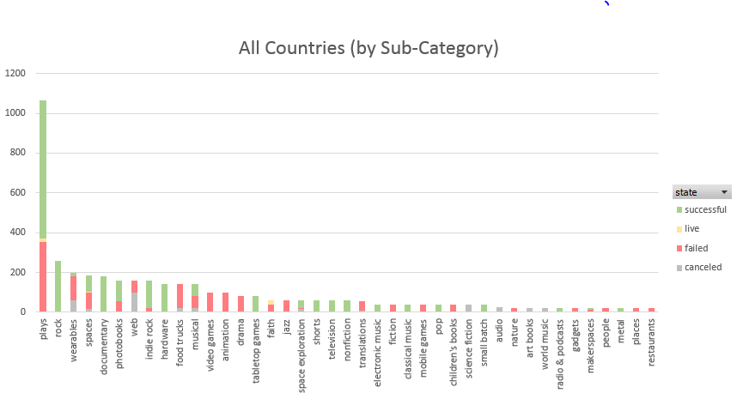

1. By looking at Sub-Category we can see why the “theater” category makes up a large percentage of all campaign types; plays alone account for a quarter of all campaign types.

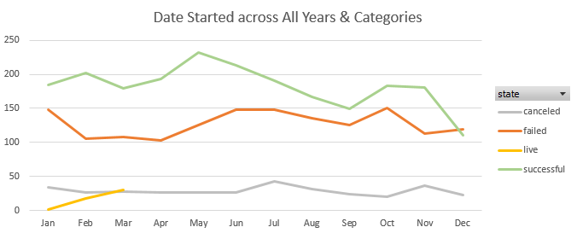

1. When looking at dates campaigns were launched across all years and categories, the most amount of successful campaigns were launched in May and the least amount were launched in December.

What are some of the limitations of this dataset?

1. We have an average donation and amount of donors, but no min/max, or distribution data per campaign to understand more about the donors and whether or not major donors were driving the support of a given campaign.

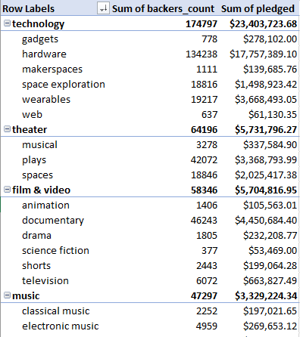What are some other possible tables/graphs that we could create?

1. I was curious as to the amount of money pledged by category. In the columns I sorted by Category then Sub-Category, and looked at Count of backers as well as Sum of amount pledged. Although Theatre had the total volume or number of campaigns, you can see now that technology has almost 3 times as many backers and over 4 times as much money pledged.
2. This can also be displayed in Pie Chart format, looking at Category by count vs Category by sum of pledged

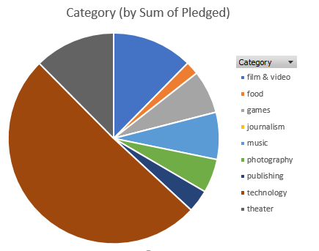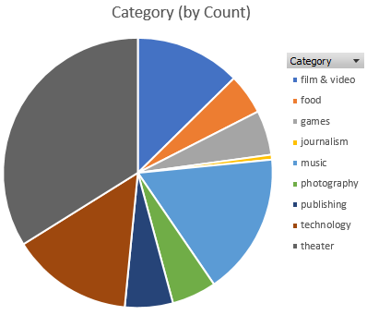

1. 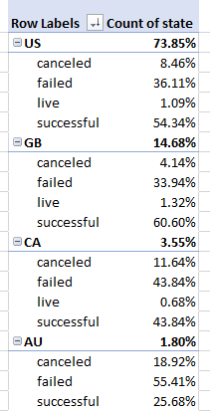To get a quick idea of breakdown of percentages of campaigns per Country, I selected Country into rows, then looked at state of the campaign per country, organized into percentage of parent category. The output then shows the percentage of campaigns of the total for each country, and what percentage within each country’s campaigns are canceled, failed, live, or successful.